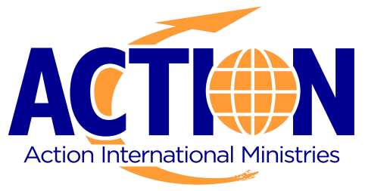

Evangelism │ Discipleship │ Development

POSITION: Pastoral Training Instructor

PLACE OF SERVICE: Lusaka, Zambia

REPORT TO: Pastor Leadership Development Coordinator

STARTING DATE: Urgently needed. Must be accepted and appointed to field by Home Office Director in ACTION UK and may go to the field after raising 100% of Mission-approved budget.

DATE REVISED: December 2013

*********************************************************************************************
PURPOSE OF THIS POSITION:
To encourage pastors and church leaders towards godliness in character and daily living. To instruct them with a precise yet practical grasp of the truth of God’s Word.
LIST OF RESPONSIBILITIES:
- Training pastors and lay-teachers by coaching them and strengthening their teaching abilities
- Coordinate Pastor Resource Center (PRC) volunteers to maintain Christian pastoral resources, including books videos and other materials.
- Research, order and distribute curriculum materials needed within the APC program
- Assess the educational needs of pastors and assist the coordinator in setting goals for their training and development
- Aid in the planning of ongoing educational programs, and short-term / one-time educational events
- Maintain an annual calendar of guest speakers and guest lecturers
- Assist with fundraising initiatives that generate support for pastoral training
- Prepare for and lead 2 leadership triad pastor groups
- Make monthly visits to the churches of APC student following a rota schedule
JOB REQUIREMENTS:

QUALIFICATIONS:
- Seminary degree preferred, minimum equivalent of BA in Theology
- 10 years pastoral experience
- Good organizational skills
- Speaks clearly and persuasively, listens and seeks clarification
- Strong facilitation and leadership skills

GENERIC BUDGET: As determined by sending office
For a Single Missionary: approximately $2-3K / mo
For a Couple Missionary w/ 1 child: approximately $4,500 / mo

LENGTH OF SERVICE: Full-time Missionary – 4+ years

LANGUAGE: English is okay as most Zambians speak English, but this person will be encouraged to study vernacular language upon arrival.

For more information: Visit: actioninternational.org & actionzambia.org
Email: info@actionuk.org ● Call: 0151-630-2451

